Security in Computing Practical 4
Configure IP ACLs to Mitigate Attacks
Practical 4: Configure IP ACLs to Mitigate Attacks
Topology:
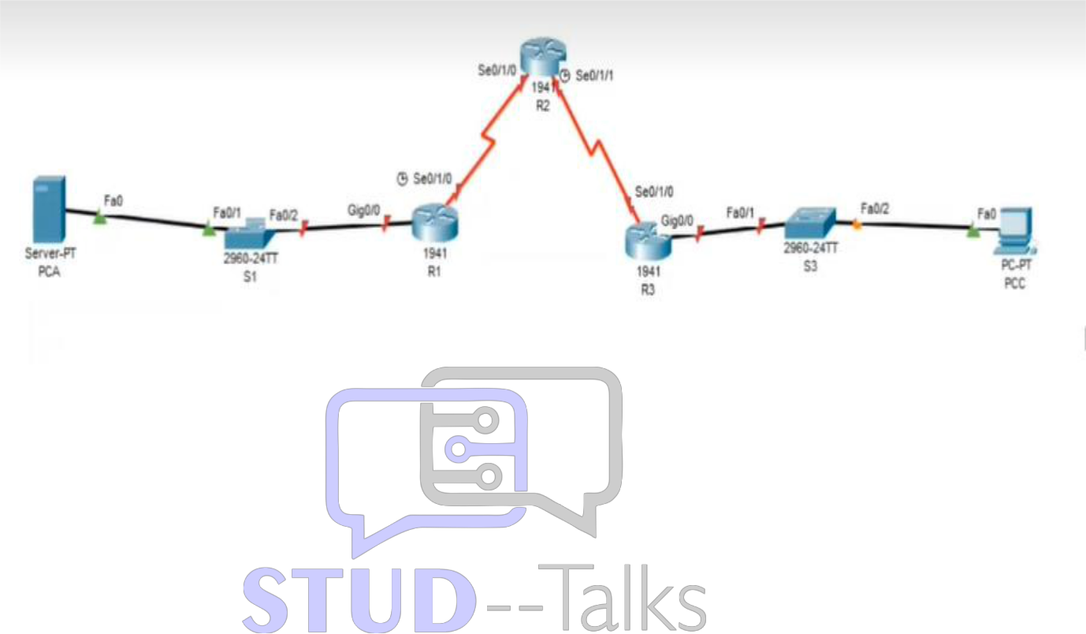

Router R1 Configuration
enable
conf t
hostname R1
enable secret enpa55
line console 0
password conpa55
login
exit
ip domain-name ccnasecurity.com
username admin secret adminpa55
line vty 0 4
login local
transport input ssh
exit
crypto key generate rsa
1024
! ACL for remote access (only PC-C)
access-list 10 permit host 192.168.3.3
line vty 0 4
access-class 10 in
exit
! ACL 120 (Attack mitigation)
access-list 120 permit udp any host 192.168.1.3 eq domain
access-list 120 permit tcp any host 192.168.1.3 eq smtp
access-list 120 permit tcp any host 192.168.1.3 eq ftp
access-list 120 deny tcp any host 192.168.1.3 eq 443
access-list 120 permit tcp host 192.168.3.3 host 10.1.1.1 eq 22
access-list 120 permit icmp any any echo-reply
access-list 120 permit icmp any any unreachable
access-list 120 deny icmp any any
access-list 120 permit ip any any
interface s0/1/0
ip access-group 120 in
exit
end
wr

Router R2 Configuration
enable
conf t
hostname R2
enable secret enpa55
line console 0
password conpa55
login
exit
ip domain-name ccnasecurity.com
username admin secret adminpa55
line vty 0 4
login local
transport input ssh
exit
crypto key generate rsa
1024
interface loopback 0
ip address 192.168.2.1 255.255.255.0
no shutdown
exit
end
wr

Router R3 Configuration
enable
conf t
hostname R3
enable secret enpa55
line console 0
password conpa55
login
exit
ip domain-name ccnasecurity.com
username admin secret adminpa55
line vty 0 4
login local
transport input ssh
exit
crypto key generate rsa
1024
! ACL 110 (inside traffic only)
access-list 110 permit ip 192.168.3.0 0.0.0.255 any
interface g0/0
ip access-group 110 in
exit
! ACL 100 (block outside attacks)
access-list 100 permit tcp 10.0.0.0 0.255.255.255 host 192.168.3.3 eq 22
access-list 100 deny ip 10.0.0.0 0.255.255.255 any
access-list 100 deny ip 172.16.0.0 0.15.255.255 any
access-list 100 deny ip 192.168.0.0 0.0.255.255 any
access-list 100 deny ip 127.0.0.0 0.255.255.255 any
access-list 100 deny ip 224.0.0.0 15.255.255.255 any
access-list 100 permit ip any any
interface s0/1/0
ip access-group 100 in
exit
end
wr

Verification Steps
1. show access-lists
2. show ip interface brief
3. Test SSH:
Only PC-C should access routers
4. Test HTTPS:
PC-C cannot access PC-A
5. Test Ping:
PC-A to R2 loopback should work after ACL fix
6. Test Attack Filtering:
Ping from outside should fail
Practical 4: ACL Security (Mitigation)
- On R1, R2, and R3:
  - show access-lists: To verify the blocking of unauthorized IP ranges (spoofing protection) and specific service ports.
- On R1:
  - show ip interface s0/1/0: To confirm ACL 120 is applied to the serial interface.
- Testing Mitigation:
  - SSH Test: Only PC-C (192.168.3.3) should be able to SSH into the routers.
  - HTTP/HTTPS Test: PC-C should be blocked from accessing the web server via port 443.

Practical 4: IP ACLs (Mitigating Attacks)
On PC-C
- SSH Restriction: Run ssh -l admin 192.168.2.1 (successful).
- HTTPS Block: Open Web Browser to 192.168.1.3 (should time out).
On PC-A
- Denied SSH: Run ssh -l admin 192.168.2.1 (should show "Connection refused").
- Ping Loopback: Run ping 192.168.2.1 (successful after ACL modification).

Viva Questions
1. What is ACL?
Used to filter traffic.
2. What is Standard ACL?
Based on source IP.
3. What is Extended ACL?
Based on source, destination, protocol.
4. Why use ACL in security?
To block unauthorized access.
5. What is mitigation?
Reducing impact of attacks.

